**Take Attendance in a Course**

Step 1: Log into Training Scheduler and

Step 2: Once you log on you should see a screen like this

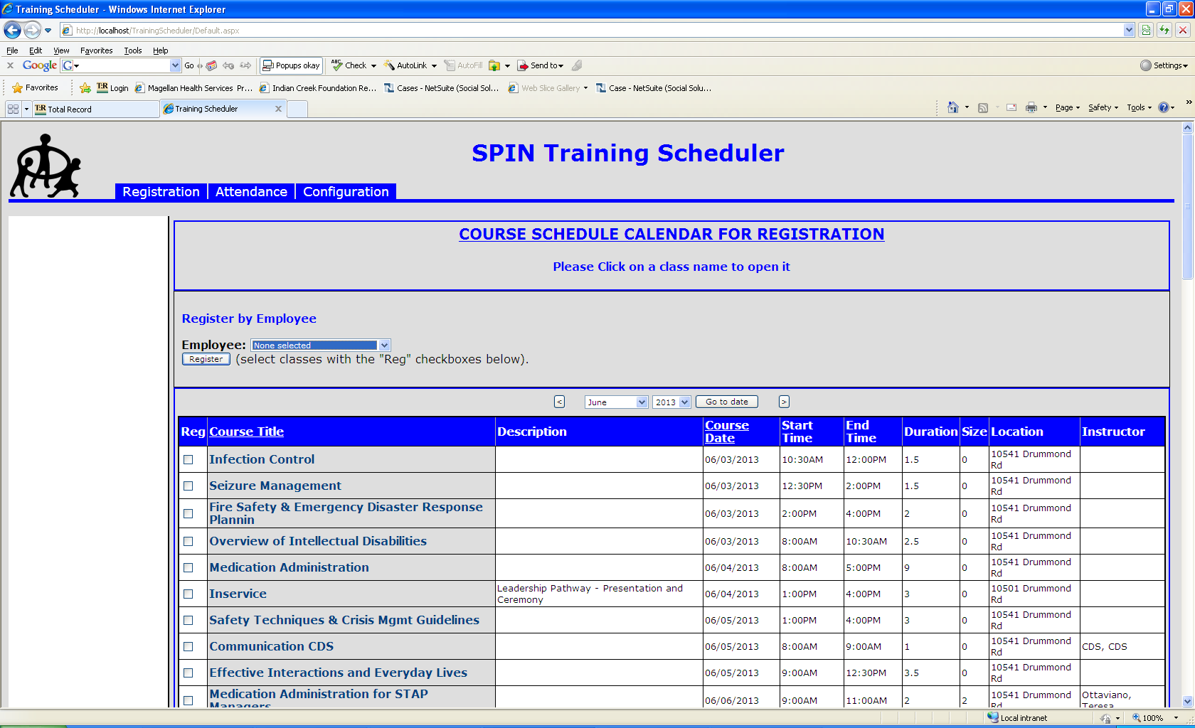

Step 3: Click on the Attendancetab. You should now see this screen.

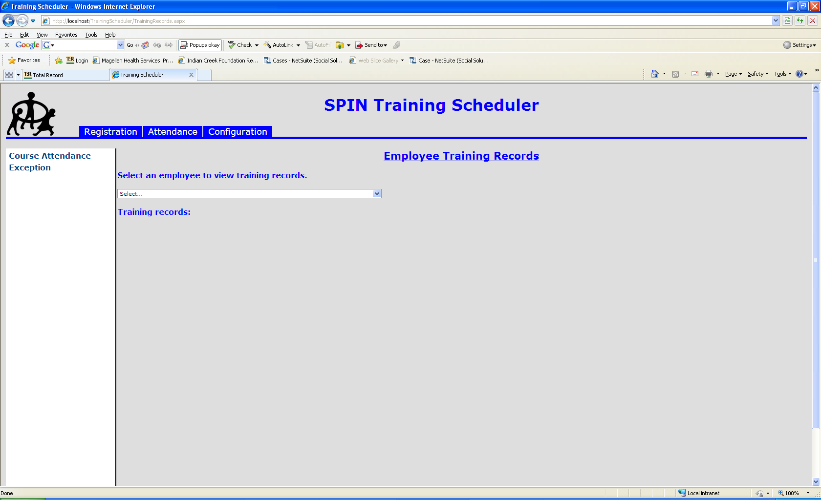

Step 4: Click on the Course Attendance link on the right hand side of the screen and you should now see this screen.

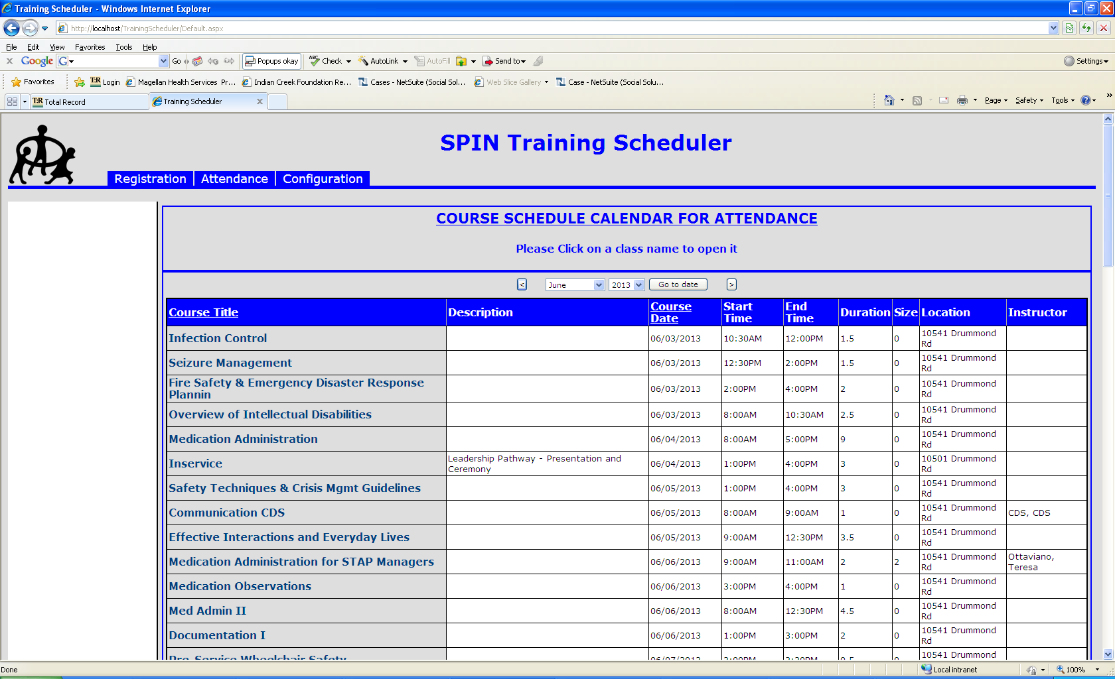

Go to the month that contains the course you want. You do that by clicking the left or right arrows or by selecting the month and year from the drop downs and clicking the go to date button in the date area of the screen.

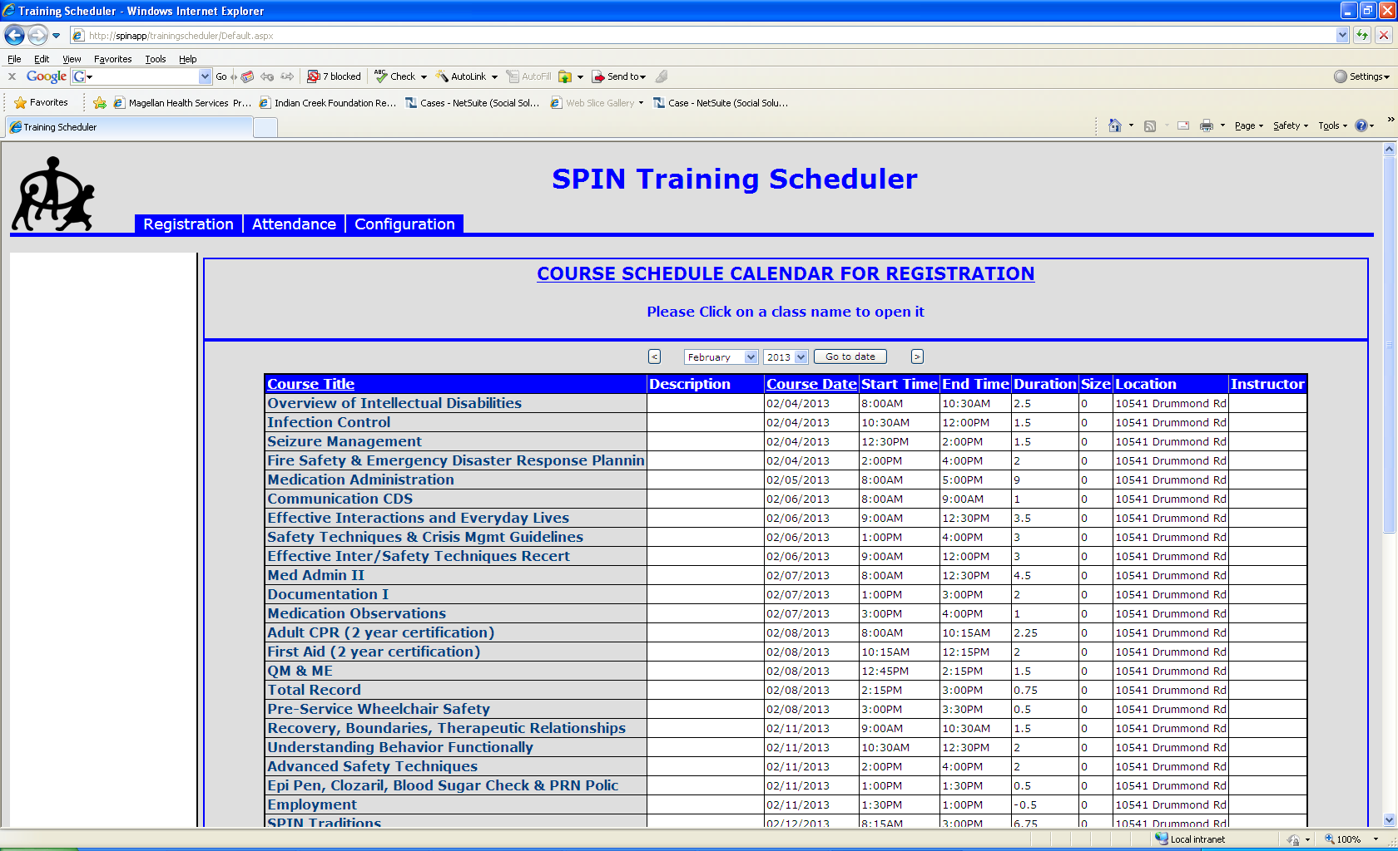

Step 5: Once on the month you want you can click on the course name you want to take attendance for and you should be brought to this screen.

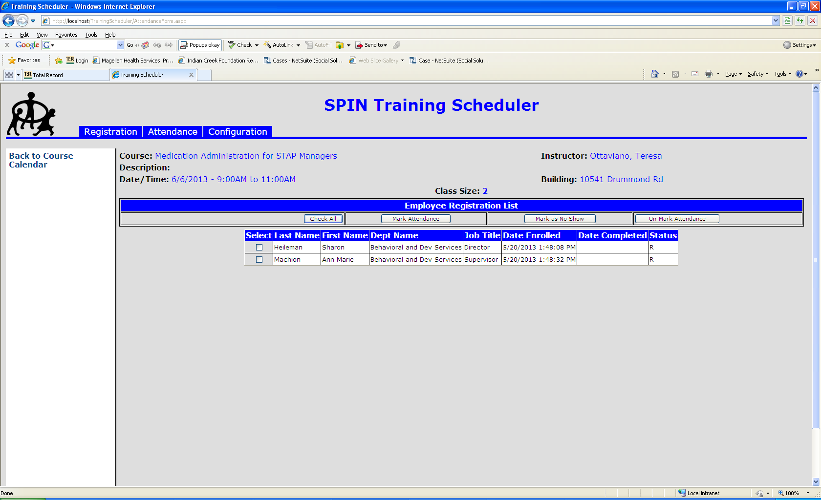

Step 6: Once on this screen you can either click on the individuals you wish to take attendance for in the Select column or press the Check All button.

Step 7: When you have the people check off you want to take attendance for you have three options to choose from



**Mark Attendance:** This button will mark all people with a check box as attended.

**Mark as No Show:** This button will mark all people with a check box as no show.

**Un-Mark Attendance:** This button will remove the attended and now show status for any person check off and will return them to the registered status.

Step 8: When you are finished taking attendance click on the Back to Course Calendar link on the right hand side of the screen and repeat steps 5 thru 7 to take attendance for another class.